

**Sexual Bias in**

**Rorschach's**

**Apperception**

**Figures**

**Swurygne Diasso**

**Baltimore City**

**Community College**

**Dr. Gail Hunter**

**PSY- 101-1344**

**Introduction to psychology**

**February 28**

**th**

**, 2025**

HISTORICAL CONTEXT

In the 1960s, the Rorschach test was widely used to diagnose homosexuality, which was then considered a psychopathology. Over the years, concerns have arisen regarding potential biases in the administration and interpretation of the Rorschach test, particularly concerning sexual bias. Researchers identified five signs believed to indicate homosexuality in Rorschach responses. However, subsequent analysis showed these signs were equally likely to appear in responses from heterosexual men, rendering them ineffective for determining sexual orientation.

A notable study by Greenberg (1972) investigated sexual bias in the administration of the Rorschach test. The research focused on whether clinician's perceptions and interpretations were influenced by the gender of the subjects. The findings indicated that while female interns exhibited cross-sex bias, experienced male clinicians did not show such bias. This suggests that the potential for sexual bias in Rorschach administration may be influenced by the clinician's experience level. ​



**Sexual Bias in**

**Rorschach**

**Administration**



A study by Alfred Wayne Coursol examined gender differences in Rorschach test responses:

Women produced significantly more color responses [C], human movement responses [HM], and positive human movement responses [H,HM,+,B or N] than men.

Gender

Differences

in

Rorschach

Responses

No significant differences were found in the number of real, whole human content responses [H] between genders.

These findings were interpreted as reflecting women's greater contact with their feelings, imagination, intelligence, and empathy compared to men.

# Influence of Societal Changes on Rorschach Responses

Ames (1975) explored how societal changes might influence Rorschach responses, particularly regarding the perception of gender in the inkblots. The study found that male subjects across different age groups increasingly saw female figures in certain Rorschach cards over time. This shift was attributed more to the age of the subjects than to the decade in which they lived, suggesting that perceptions elicited by the Rorschach test can evolve with societal changes and may reflect shifting gender roles.



While these studies provide valuable insights into potential sexual biases in the Rorschach test, it's important to note that more recent research may have further refined our understanding of this topic. Additionally, modern interpretations of the Rorschach test likely take these potential biases into account when analyzing results.



A 1972 study by R.P. Greenberg specifically examined

sexual bias in Rorschach administration, suggesting that the

way the test is administered could potentially introduce

bias7.

# CONCLUSION

Research has shown that women tend to produce more color and human movement responses than men, possibly indicating greater emotional expressiveness and empathy. However, both genders perceive whole human figures at similar rates. Perceptions of gender within the inkblots themselves tend to skew towards female figures, regardless of the respondent's gender. Responses have evolved over time, challenging traditional interpretations. While gender differences exist, they interact with other factors like age, ethnicity, and education.

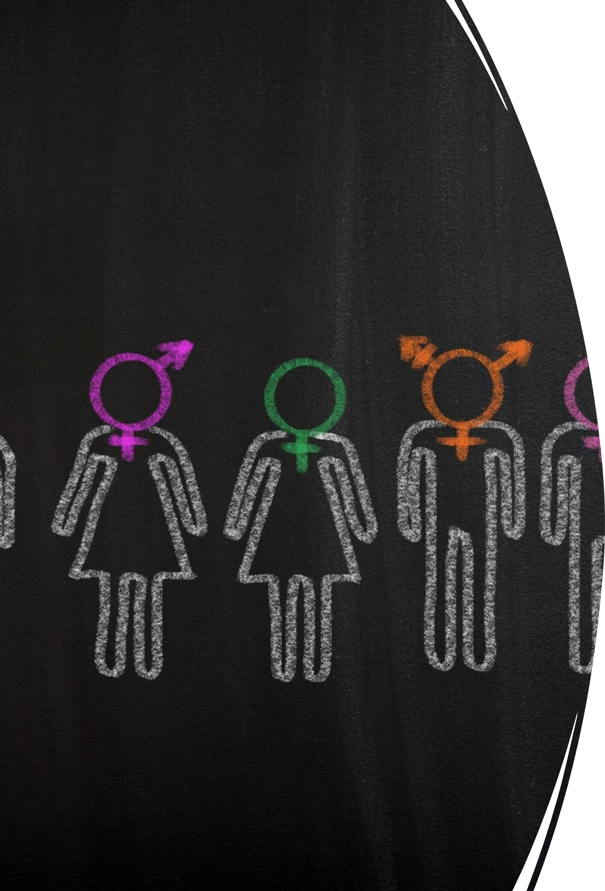

These findings highlight the importance of considering gender in Rorschach test interpretation, but also emphasize the need for nuanced, individualized analysis that takes into account multiple demographic factors.

|  |  |
| --- | --- |
| R | EFERENCES  , A. W. (1995). Gender differences on the Rorschach |
| Coursol |
| test. Do | ctoral Dissertation, University of Tennessee.  woro, C. A., Hanum, L., Megawati, A. H., Hutahaean, B. |
| Dannis |
| S. H., & | Poerwandari, E. K. (2021). The content analysis of |
| Rorsch | ach in attesting the sex offenders. Journal Psychology, |
| 48(3), 2 | 28-239.  erg, R. P. (1972). Sexual bias on Rorschach |
| Greenb |
| adminis | tration. Journal of Personality, 36(4), 336-339 J. M., Gacono, C. B., & Cunliffe, T. B. (2018). |
| Smith, |
| Compa | rison of male and female psychopaths on select CS |
| Rorsch | ach variables. Journal of Personality Assessment |
|  |